# **Question 1:**

Syed Ahsan Akhtar Naqvi

OS LAB

Section 4H

19K-1475

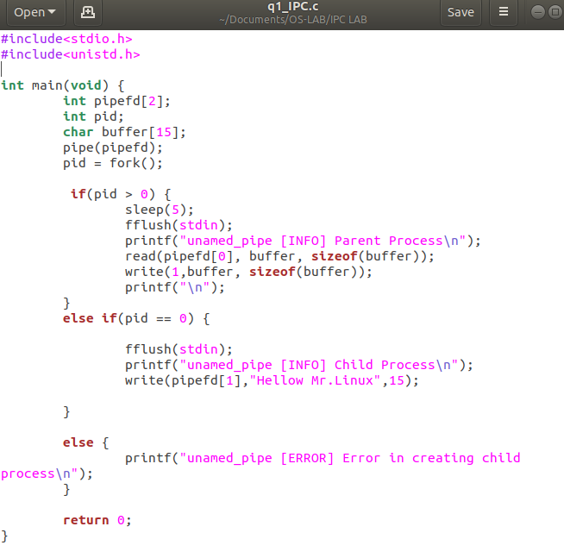

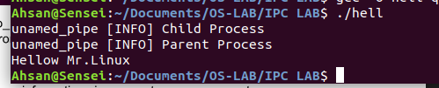

# **QUESTION 2:**

**Read Processes:**

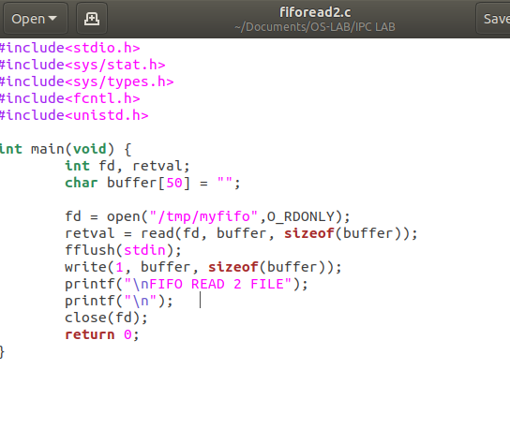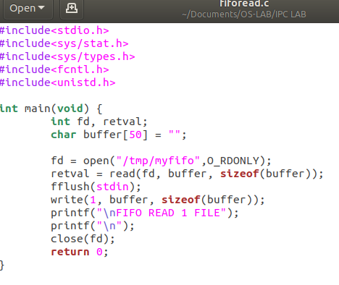

**WRITE PROCESS:**

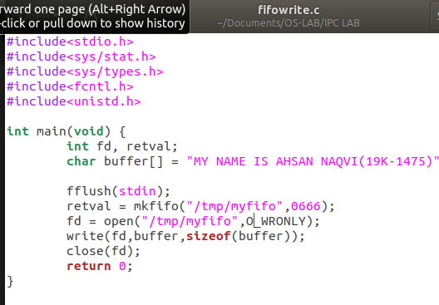

**WRITE OUTPUT:**

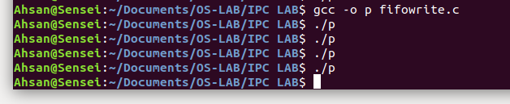

**READ OUTPUT:**

